SiteSense — Data Center Impact Explorer: Build Plan
Oct 3, 2026 · @Sina

Concept & pitch
Drop a data center anywhere on the map, set its size, and see who wins and who pays: power, carbon, water, jobs, taxes, hazards and the people nearby. Then ask an AI analyst about it, and let it suggest a better site.
- One-liner: "Data centers are being sited faster than communities can evaluate them. SiteSense turns 15+ public geospatial datasets into a 10-second impact report for any parcel, and points to where the impact would be lower."
- Personas: a county commissioner reviewing a rezoning request; a resident who just heard a 300 MW campus is coming; a developer screening sites.
- Why it fits the CGA track: the prompt asks for a tool that "helps determine where to take action." Our action is the Better Site finder and a ranked list of mitigations (closed-loop cooling, on-site solar, setback distance), not just a heat map.
- Why it scores on the general rubric: Track = siting is a live NC issue; Technology = multi-layer spatial joins + radar-derived ground stability + a siting model trained on our A100s + a Gemini analyst whose tool calls move the map; Design = one click, plain-language cards; Execution = precomputed grid keeps the live demo instant.
- Name is a placeholder. Pick one in the first 10 minutes so the domain, repo and DevPost match.

Scope decisions
Go deep on North Carolina, run coarse anywhere in the US, and say so on screen. "Anywhere on Earth" is not doable well in 22 hours; a polished NC demo beats a shaky global one, and NC is the judges' home turf.
Tier 1 — North Carolina (full detail): every dataset below, precomputed on a hex grid, plus NC OneMap layers. The demo runs here.
Tier 2 — rest of the US (live lookups only): grid carbon, Census, flood zone, hazard index, water stress. Cards that lack data show "not available outside NC" instead of a fake number.
What the user sets when they drop a pin:
Input | Options | Default
IT load | 20 / 50 / 100 / 300 / 1000 MW (slider) | 100 MW
Cooling | Evaporative, Air (dry), Closed-loop liquid | Evaporative
Power source | Grid, Grid + on-site solar, On-site gas turbines | Grid
Workload | AI training (high utilization), Mixed cloud | AI training
Not building: user accounts, a real hydrology or power-flow simulation, parcel ownership, global coverage, mobile app. Sketch any of these on the "future work" slide instead.

Architecture
A static Leaflet site talks to one FastAPI service; the service reads a precomputed hex grid, makes a few live lookups, and forwards context to the Gemini API.
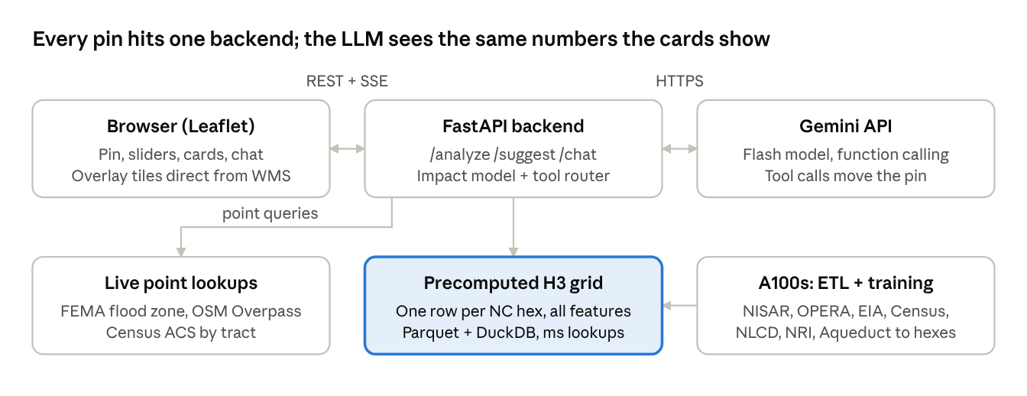
system architecture · 6 components
The highlighted grid is what keeps the live demo instant: every slow raster join happens tonight, not at the judging table.
- Frontend: plain HTML/JS + Leaflet (or Vite + vanilla/React if the undergrad prefers). Chart.js for small charts. Hosted on GitHub Pages or Vercel; register a GoDaddy domain.
- Backend: Python 3.11, FastAPI, GeoPandas, Shapely, h3, DuckDB, rasterio/rioxarray, httpx. Hosted on Render or Railway, or a teammate's laptop. The A100 server is offline-only: ETL and training.
- Grid: H3 resolution 7 (about 5 km² per hex, roughly 27,000 hexes over NC). Each hex carries every feature in the Datasets table plus the trained pressure score. A pin snaps to its hex, then live lookups refine the exact point.
- Exposure: the backend needs a public HTTPS URL (Render/Railway give one; a laptop needs Cloudflare Tunnel or ngrok). Set CORS to the frontend domain. Copy the finished grid Parquet off the GPU server so the demo never touches it.
- Contract first: both people build against the JSON in the API contract section. Frontend uses a mock JSON file until the real endpoint is up.

Datasets
P0 rows make the demo work; P1 rows make it complete; P2 only if time allows. B = backend owns the ETL, F = frontend adds it as a map overlay straight from the provider's tile service.
Dataset | What it measures | How we use it | Owner | Priority
EPA eGRID | CO₂ lb/MWh and fuel mix by grid subregion | Annual carbon of the site; "how clean is this grid" | B | P0
EIA-860 + EIA state prices | Power plants, capacity, fuel; retail price by state | Nearby generation, electricity cost, ratepayer impact | B | P0
OSM power lines + substations (Overpass) | Transmission lines and substations with voltage tags | Distance to nearest ≥115 kV line / substation = grid hookup cost | B (F overlay) | P0
HIFLD transmission lines mirror | Same, more complete; HIFLD Open itself was taken down | Fallback/cross-check for OSM | B | P1
WRI Aqueduct | Baseline water stress (0–5) by watershed | Water card: cooling draw vs. local stress | B | P0
US Drought Monitor | Current drought category | Water card context; live map overlay | F | P1
NOAA Climate Normals | Temperature, cooling degree days | Adjusts PUE and cooling water | B | P1
FEMA NFHL | 100/500-yr flood zones | Point-in-zone check; overlay | B + F | P0
FEMA National Risk Index | Tract-level risk for 18 hazards, social vulnerability, resilience | Hazard card (hurricane, heat, flood, tornado) | B | P0
OPERA DISP-S1 | InSAR ground displacement, 30 m, North America, 2016 on | Ground stability / subsidence score | B | P1
NISAR L2 GCOV | L-band radar backscatter (HH, HV); provisional data from June 17, 2026 | Radar view of demo area: HV = canopy/biomass to be cleared, low HH = wet ground | B (F overlay) | P1
NLCD | Land cover, 30 m | Acres of forest/farm/wetland converted | B | P0
National Wetlands Inventory + PAD-US | Wetlands; protected lands | Hard flags: "site is in a wetland / protected area" | B | P1
USGS 3DEP | Elevation, slope | Grading difficulty; low-lying flag | B | P2
Census ACS | Population, income, poverty, age by tract | People within 1/3/5 km; who bears the impact | B | P0
CDC/ATSDR Social Vulnerability Index | Tract vulnerability percentile | Equity flag (replaces EJScreen, which EPA removed in Feb 2025) | B | P0
BLS QCEW + LAUS | County jobs, wages; unemployment rate | Jobs card: new jobs vs. local labor force | B | P0
NC county property tax rates (NC Dept. of Revenue) | Rate per $100 of value | Tax revenue estimate | B | P1
OSM schools, hospitals, homes (Overpass) | Sensitive sites and buildings | Noise/diesel exposure within 1 km | B | P0
EPA Green Book | Ozone/PM nonattainment areas | Flag for backup diesel generator permits | B | P2
FCC Broadband Map | Fiber availability | Connectivity score for siting | B | P2
OSM telecom=data_center | Existing data centers | Training labels for the siting model (US-wide) + overlay | B + F | P0
NC OneMap | NC parcels, zoning, hydrography | Optional NC detail layers | F | P2
NISAR reality check: provisional GCOV, GSLC and RSLC products are on ASF; a ready-made interferogram (GUNW) product is not listed yet, so use OPERA DISP-S1 for subsidence and NISAR GCOV for the radar story. Files are large HDF5; make the Earthdata login and start one demo-area download in the first hour.

Impact model
Keep it transparent: simple formulas, every constant in one assumptions.yaml, every number in the UI traceable to a dataset. Judges trust a clear model more than a black box.
Energy and carbon
E_{\text{yr}}\,[\text{MWh}] = P_{IT} \times \text{PUE} \times U \times 8760

\text{CO}_2\,[\text{t/yr}] = \frac{E_{\text{yr}} \times r_{\text{eGRID}}\,[\text{lb/MWh}]}{2204.6}
Show it as "powers the equivalent of N homes" (N = E × 1000 / 10,500 kWh) and "adds X% to the county's electricity use."
Water
W_{\text{yr}}\,[\text{L}] = E_{\text{yr}} \times 1000 \times (\text{WUE}_{\text{site}} + \text{EWIF}_{\text{grid}})
Split on-site (cooling) from off-site (power plants). Multiply the on-site share by the Aqueduct stress level to get a "water pressure" score, and translate to households' daily water use.
Economy: construction jobs, permanent jobs, annual property tax = capex × taxable share × county rate / 100, and the annual power bill = E × state industrial price. Compare jobs to the county's unemployed count and tax to the county's levy so the numbers mean something locally.
Hazards and ground: FEMA flood zone (in/out), NRI scores per hazard, OPERA subsidence rate (mm/yr), wetland/protected flags.
Community: population within 1, 3 and 5 km; SVI percentile; schools, hospitals and homes within 1 km (noise and generator exhaust); land converted by NLCD class.
Two scores, not one. Normalize each metric to its percentile across all NC hexes, then combine:
- Site Suitability (0–100) — the developer's view: grid access, water availability, low hazard, flat land, fiber.
- Community Burden (0–100) — the residents' view: water pressure, carbon, people and vulnerable groups nearby, land converted; minus benefits (jobs vs. unemployment, tax vs. levy).
Plot the site on a suitability × burden quadrant. The goal is high suitability, low burden.
Better Site finder (the "where to take action" feature): search hexes within 50 km, drop any with a hard flag (flood zone, wetland, protected land), rank by suitability − burden, return the top 3 with deltas ("−38% water pressure, 2,100 fewer residents within 3 km"). Mitigation toggles recompute the same site with closed-loop cooling, solar, or a larger setback and show the change.
Siting Pressure model (trained on the A100s): predicts where developers are likely to build next, so a county can prepare before a proposal lands. This is the second "where to take action" answer.
- Labels: hexes containing an existing US data center (OSM telecom=data_center) = positive; a random sample of other hexes = unlabeled background.
- Features: the nationally available hex features: distance to ≥230 kV lines and substations, grid carbon and price, water stress, NRI hazards, population density, land cover, flood share, fiber.
- Model: GPU XGBoost or LightGBM as the main model, a small PyTorch MLP to compare. Treat it as positive-unlabeled learning and present the output as a relative "pressure" score, not a probability.
- Validation: spatial cross-validation (hold out whole states) so neighbors don't leak; put the AUC on a slide. CGA judges will look for this.
- Outputs: a pressure score per NC hex for a heat-map layer, plus the top 3 SHAP drivers per hex that Gemini can explain ("high pressure here mainly because of the 500 kV line 2 km away").
- Where the GPUs earn their keep: building the US-wide feature grid (raster zonal stats, NISAR HDF5 processing) and hyperparameter sweeps. The model itself trains in minutes.
- Stretch only: a U-Net for water/wet-ground mapping trained on a labeled SAR flood dataset, applied to NISAR scenes. Expect domain shift between sensors.
Starting assumptions (approximate, from industry reports; verify and cite in the README before the demo):
Parameter | Evaporative | Air (dry) | Closed-loop liquid
PUE | 1.2 | 1.4 | 1.15
On-site WUE (L/kWh) | 1.8 | 0.2 | 0.1

Parameter | Starting value
Utilization U | 0.8 AI training, 0.6 mixed cloud
Off-site water EWIF (L/kWh) | ~4.5 US average; replace with a regional figure if found
Average home electricity | ~10,500 kWh/yr (EIA)
Land | ~0.75 acre per MW
Capex | ~$10M per MW
Construction jobs (peak) | ~10 per MW
Permanent jobs | ~0.5 per MW
On-site gas turbines | ~900 lb CO₂/MWh instead of eGRID

API contract
Final version: contract/CONTRACT.md in the geohack folder, with schemas.py (source of truth), generated mocks, a stub server and api.js. No field renames after 3 PM. The summary below matches it. The backend commits mock/analyze.json with this exact shape first so the frontend is never blocked.
Endpoint | Purpose | Returns
POST /api/analyze | Full impact report for one pin + config | Report JSON (below)
POST /api/suggest | Top 3 better sites within a radius | List of {lat, lon, hex_id, scores, deltas, reason}
GET /api/layers/{name} | Precomputed GeoJSON layers: suitability, burden, subsidence, water_stress, pressure | GeoJSON FeatureCollection of hexes
POST /api/chat | Chat with the analyst; streams tokens | Server-sent events: token, tool_call, done
GET /api/health | Demo-day sanity check | {ok, llm_ok, grid_rows}
Request (/api/analyze, /api/suggest add radius_km):
{ "lat": 35.7796, "lon": -78.6382, "mw": 100,
"cooling": "evaporative", "power": "grid", "workload": "ai" }
Report (values are placeholders showing the shape only):
{
"site": { "lat": 35.7796, "lon": -78.6382, "hex_id": "872af...", "county": "Wake", "state": "NC", "tier": 1 },
"scores": { "suitability": 0, "burden": 0, "quadrant": "good|tradeoff|poor|avoid", "pressure": 0, "pressure_drivers": ["near_230kv_line"] },
"energy": { "annual_mwh": 0, "homes_equiv": 0, "county_share_pct": 0, "grid_region": "SRVC", "annual_cost_usd": 0, "nearest_substation_km": 0 },
"carbon": { "tons_co2_yr": 0, "cars_equiv": 0, "grid_lb_per_mwh": 0 },
"water": { "onsite_m3_yr": 0, "offsite_m3_yr": 0, "households_equiv": 0, "aqueduct_stress": 0, "drought": "D0" },
"economy": { "construction_jobs": 0, "permanent_jobs": 0, "county_unemployed": 0, "property_tax_usd_yr": 0, "county_levy_share_pct": 0 },
"hazards": { "fema_zone": "X", "nri": { "hurricane": 0, "heat": 0, "riverine_flood": 0, "tornado": 0 }, "subsidence_mm_yr": 0 },
"community":{ "pop_1km": 0, "pop_3km": 0, "pop_5km": 0, "svi_pct": 0, "schools_1km": [], "hospitals_1km": [], "homes_1km": 0 },
"land": { "acres": 0, "converted": { "forest": 0, "cropland": 0, "wetland": 0, "developed": 0 }, "flags": ["in_wetland"] },
"mitigations": [ { "name": "closed_loop_cooling", "delta": { "water.onsite_m3_yr": -0.0 } } ],
"sources": [ { "key": "egrid", "name": "EPA eGRID", "url": "https://www.epa.gov/egrid" } ],
"missing": [ "subsidence_mm_yr" ]
}
Chat: request { "messages": [...], "report": <Report>, "config": <AnalyzeRequest> }; the response streams SSE events token, tool_call, report, suggestions, done, error. The backend runs the tools itself; on a report event the frontend moves the pin and re-renders, on suggestions it drops ghost pins. Nothing is posted back.

LLM plan
The chat runs on the Gemini API. The A100s are offline-only: heavy preprocessing and training the siting pressure model (see Impact model), so nothing at demo time depends on the GPU server. Function calling is still the "wow" moment: "try it 20 km east with closed-loop cooling" and the map updates.
Serving
- Model: the current Flash model on the Gemini models page (gemini-3.8-flash as of today), with Flash-Lite as the fallback. Keep the model ID in config so a swap is one line.
- SDK: pip install google-genai. The key lives in the backend env var GEMINI_API_KEY, never in the browser.
- Streaming: the backend calls client.models.generate_content_stream(...) with system_instruction and tools in the config, and forwards chunks to the browser over SSE.
- Function calling: declare each tool below; when Gemini returns a function call, the backend runs it, sends the result back, and streams the final answer.
- Rate limits: cache answers for the 3 demo sites and keep the second teammate's key as a backup.
Grounding (system prompt)
- Role: neutral siting analyst explaining trade-offs to a non-expert, in plain language, under 150 words unless asked for more.
- Context injected every turn: the current report JSON, the user's config, the assumptions table, and the source list.
- Rules: use only numbers from the report; name the dataset when quoting a number; say "not available" for anything in missing; always give both benefits and costs; end with one concrete mitigation or a better-site suggestion.
Tools the model can call
Tool | Args | Backend action
geocode | place | Nominatim (OSM) lookup, 1 request/second
move_site | lat, lon | Re-run analyze; frontend moves the pin
set_config | mw, cooling, power | Re-run analyze with new settings
find_better_sites | radius_km | Call /api/suggest; frontend drops 3 ghost pins
compare | site_a, site_b | Return both reports side by side
Starter chips in the chat box: "Is this good for my town?" · "What happens to our water?" · "How many local jobs, really?" · "Where would be better?"

Frontend tasks (undergrad)
Owns everything the judges see and touch, plus the pitch materials. Builds against mock/analyze.json until the real API is live.
M1 — skeleton (by 3 PM Sat)
- ☐ Repo scaffold, GitHub Pages/Vercel deploy working on an empty page
- ☐ Full-screen Leaflet map, dark basemap (CARTO Dark Matter), centered on NC
- ☐ Click to drop a draggable data-center pin; sidebar config: MW slider, cooling, power, workload
- ☐ api.js wrapper with one BASE_URL switch between mock and live
- ☐ Report sidebar with tabs: Overview · Energy & Carbon · Water · Jobs & Taxes · Hazards · Community
M2 — real data + chat (by 7:30 PM Sat)
- ☐ Overview: two score gauges + suitability × burden quadrant with the site dot
- ☐ Cards with plain-language comparisons ("= 74,000 homes", "= 3% of county water") and a source link on every card
- ☐ Buffer rings at 1/3/5 km; markers for schools and hospitals inside 1 km
- ☐ Chat panel: streaming SSE text, starter chips, "thinking" state, error retry
- ☐ Handle tool_call events: move the pin, update config, re-fetch report
M3 — wow features (by midnight)
- ☐ Layer switcher: suitability, burden and siting-pressure hex heat maps (/api/layers), FEMA flood zones, transmission lines, drought, existing data centers, NISAR radar view
- ☐ "Find a better site" button: 3 ghost pins with delta badges; click one to compare side by side
- ☐ Mitigation toggles that re-run analyze and animate the changed numbers
- ☐ Loading skeletons, empty states, "not available outside NC" badges
M4 — polish + pitch (Sun 9–10:30 AM)
- ☐ Landing overlay: one sentence + "Drop a data center" button; guided first-run tooltip
- ☐ Accessibility: keyboard focus, color-blind-safe palette, readable contrast
- ☐ 2-minute demo video, DevPost screenshots, 4-slide pitch deck
- ☐ Optional: ElevenLabs "read this report aloud" button

Backend tasks (grad)
Owns data, the impact model, the API and the LLM. First job is to unblock the frontend with the mock file; second is to start the slow downloads.
M1 — unblock + kick off downloads (by 3 PM Sat)
- ☐ Commit mock/analyze.json matching the API contract (first 30 min)
- ☐ Start downloads in the background: NLCD NC clip, OPERA DISP-S1 frames over the Triangle, one NISAR GCOV scene over the demo county (needs an Earthdata login)
- ☐ Get a Gemini API key (one per teammate as backup); confirm a function-call round-trip with the google-genai SDK
- ☐ FastAPI skeleton with /health, /analyze returning mock; deployed to Render/Railway (or laptop + Cloudflare Tunnel), URL shared with frontend; CORS set
M2 — real numbers + chat (by 7:30 PM Sat)
- ☐ Build the NC H3 res-7 grid; join P0 tables: eGRID subregion, Aqueduct stress, NRI tract scores, ACS tract population/income, SVI, QCEW/LAUS county jobs, NLCD class shares
- ☐ Overpass pulls for NC: power lines, substations, schools, hospitals; cache to GeoParquet
- ☐ impact.py with all formulas reading assumptions.yaml; unit-test against one hand-calculated site
- ☐ Live point lookups: FEMA NFHL flood zone, exact distances to substation/line and sensitive sites
- ☐ /api/chat with system prompt, report injection, SSE streaming, tool executor (move_site, set_config, geocode)
M3 — action features (by midnight, can run remote)
- ☐ Percentile normalization over all NC hexes; suitability and burden scores
- ☐ /api/suggest (radius search, hard-flag filter, top 3 with deltas) + find_better_sites tool
- ☐ /api/layers/* GeoJSON (simplify to keep each under ~5 MB)
- ☐ P1 joins: OPERA subsidence rate per hex, wetlands/PAD-US flags, NOAA cooling degree days into PUE
- ☐ NISAR GCOV: convert HH/HV to dB, clip to the demo county, export a colorized PNG/COG overlay with bounds for Leaflet
- ☐ On the A100 server: build the US-wide training grid, train the siting pressure model with spatial CV, write scores + top drivers into the NC grid
M4 — harden (Sun 9–10:30 AM)
- ☐ Cache reports for the 3 demo sites so the pitch never waits
- ☐ README: setup, data sources with links, assumptions, AI-usage citation (required by the rules)
- ☐ Freeze the server; no restarts after 10:30 AM

Timeline & milestones
Feature-freeze at 10:30 AM Sunday; everything after that is rehearsal. Each milestone ends with a 10-minute sync where both people run the app end to end.
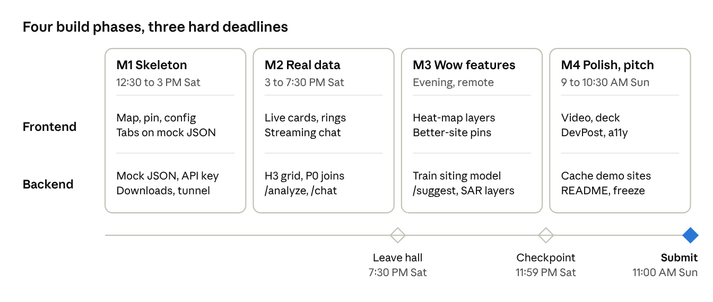
build timeline · 4 phases, 3 deadlines
Judging starts 12:30 PM Sunday at your table; closing ceremony at 3 PM.
- 12:30–1:00 PM Sat (together): pick the name, agree on the API contract, create the repo, register on DevPost, choose the 3 demo sites.
- Sync points: 3 PM, 5:30 PM, 7:15 PM (before leaving), 11 PM online, 9 AM Sunday.
- Cut rule: if a P1 item isn't working by its milestone, drop it and polish what works. A smaller app that never breaks beats a bigger one that stalls on stage.

Opt-ins, demo, risks, submission
Opt-in challenges (opting in costs nothing; only build the cheap ones):
- GoDaddy domain — 10 minutes with promo code MLHWH2697. Do it.
- ElevenLabs — "read my report aloud" button, ~45 minutes. Worth it if M3 is done.
- Gemini API — the analyst chat runs on it now, so opt in and show function calling moving the map in the video.
- Data Streaming Challenge — written for the Applied AI tracks; ask an organizer before counting on it.
3-minute demo script
- Hook (20 s): "NC is one of the hottest data center markets, and counties often decide on rezonings with little independent analysis. SiteSense gives anyone that analysis in 10 seconds."
- Drop a pin (40 s): a 300 MW evaporative campus at demo site 1. Walk the cards: homes-equivalent power, water vs. Aqueduct stress, 1 km schools, jobs vs. unemployed.
- The science (30 s): show the pressure map ("our model, trained on A100s, predicts where the next data centers will land"), then toggle subsidence and the NISAR radar view: "radar sees ground movement and canopy that optical images miss."
- Ask the AI (40 s): "Is this good for my town?" then "Try closed-loop cooling and find a better site within 40 km." The pin moves on its own.
- Action (30 s): the better site cuts water pressure and residents nearby; show the quadrant shift.
- Close (20 s): "Every number links to its public source. Built on 15+ datasets, a siting model we trained, and Gemini."
Risks and fallbacks
Risk | Fallback
Venue Wi-Fi or tunnel dies | Phone hotspot; frontend switches to cached reports for the 3 demo sites
Gemini rate limit or outage | Back off and retry on Flash-Lite; cached answers for the 3 demo sites; pre-recorded chat clip in the video
NISAR download or parsing eats hours | Ship OPERA subsidence only; show one NISAR quick-look image
Overpass rate limits | Pull NC once tonight and cache; never query live during the demo
Raster joins too slow | Sample raster at hex centroids instead of zonal stats
Numbers look wrong to a judge | Assumptions panel in the UI; every card shows its formula and source
Submission checklist
- ☐ Team + track set on DevPost and the portal by 11:59 PM Sat (mandatory)
- ☐ Public GitHub repo; README with setup, data sources, assumptions, and AI-usage citation
- ☐ DevPost: description, 2-minute video, screenshots, live link, opted-in challenges, by 11:00 AM Sun
- ☐ Laptop charged, demo tab open on demo site 1, hotspot ready, at the table by 12:30 PM
Sources checked for this plan: NISAR data availability (ASF) · OPERA DISP-S1 release (NASA Earthdata) · HIFLD Open transmission lines mirror · EPA removes EJScreen (EDGI) · Gemini API models

